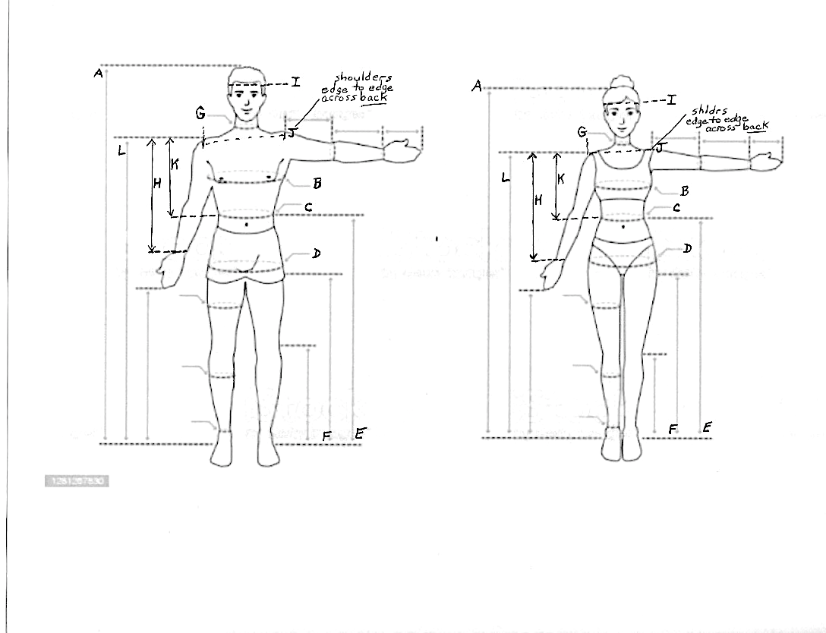

**PLEASE USE ACCURACY FOR ALL MEASUREMENTS – Costume fit depends on accurate measurements!**

A – Height G – Neck (where shirt collar would sit)

B – Chest or Bust at fullest part H – Sleeve Length (from shoulder edge to wrist bone)

C – Waist (above bellybutton) I – Hat/Head (circumference around head above ears)

D – Hip at fullest part J – Shoulders (across BACK between shldr edges)

E – Outseam (waist to floor-NO shoes) K – Shoulder to Waist (measure at BACK from top of shoulder to waist)

F – Inseam (crotch to floor) L – Shoulder to Floor (measure at BACK from top of shoulder to floor-NO shoes)

**USE MEASUREMENT CHART TO FILL IN ABOVE INFORMATION**

**DIAGRAMS for taking MEASUREMENTS**

**Please use a soft tape measure, have a responsible adult taking measurements**